Bash scripting -2

- Create a bash script to check if a directory is available or not.
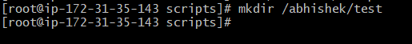

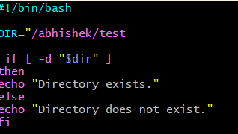

Create a abhishek.bash give 755 permissions Check the output using ./abhishek.bash

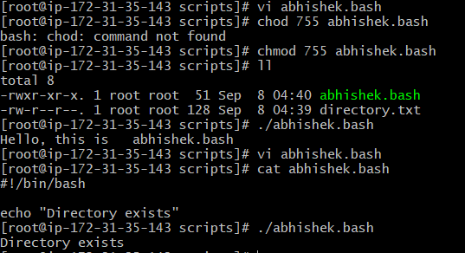

- Create a bash script to create multiple files
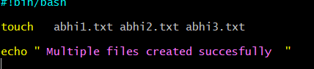

- Create a bash script totake a backup of a directory.
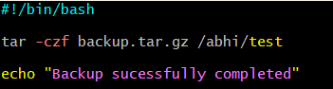

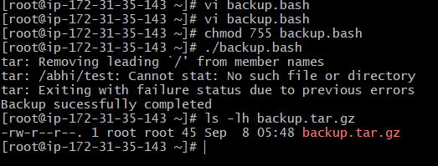

- Create a bash script to install Nginx on an EC2 server
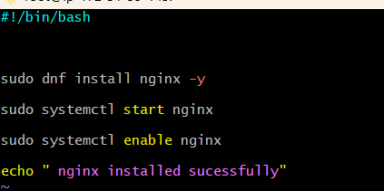

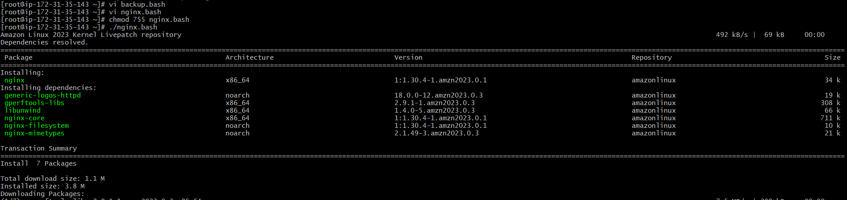

- Create a bash script to install Apache Tomcat on an EC2 server.

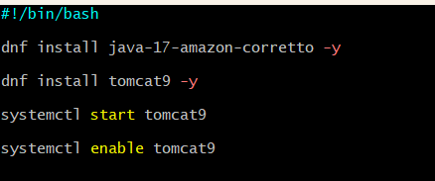

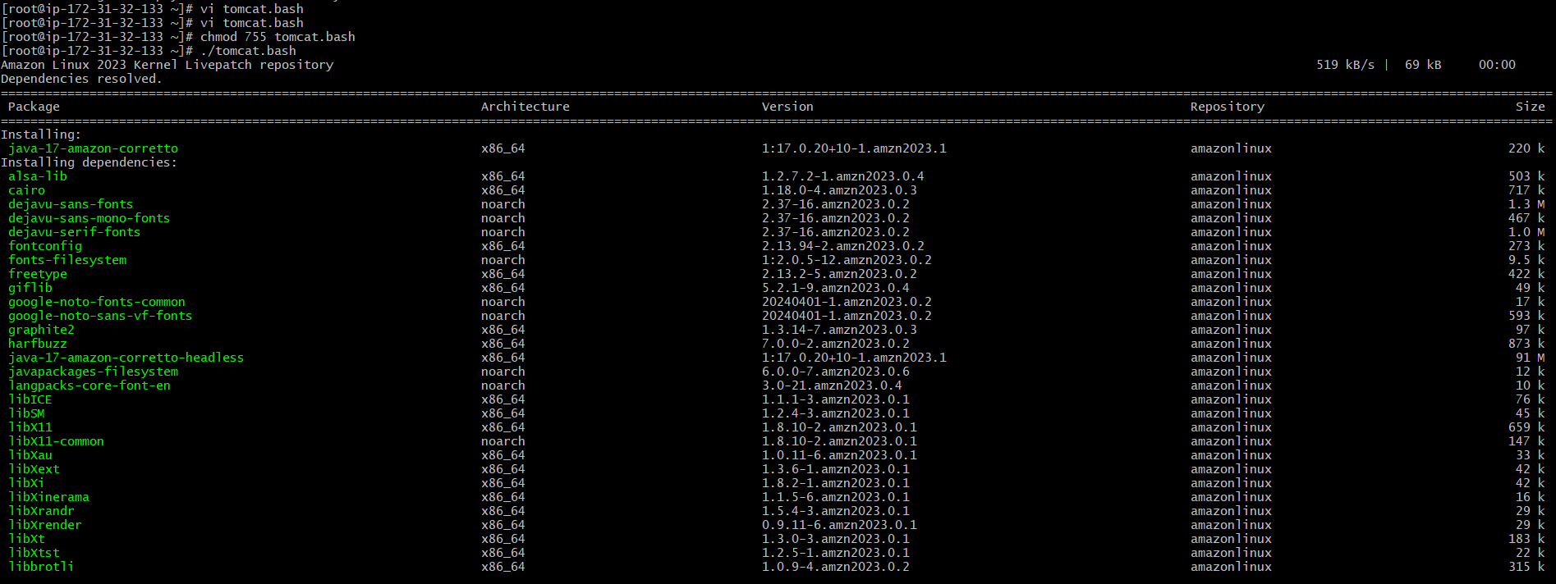

- Create a bash script to check if the Nginx service is running, if not running then script should start the service. Create vi check nginx.bash
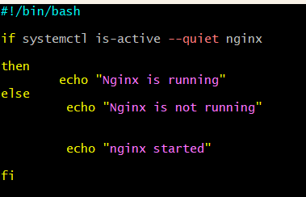

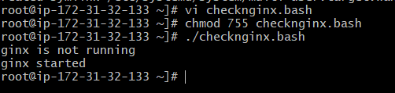

- Create a bash script for a calculator. Create vi calculator.bash

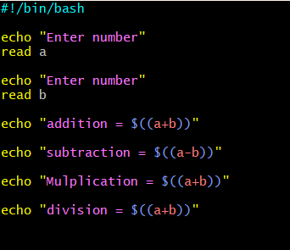

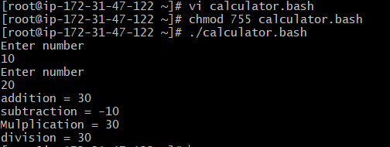

- Create a bash script to check if a directory exists, if not then create a directory. Create vi create dir.bash
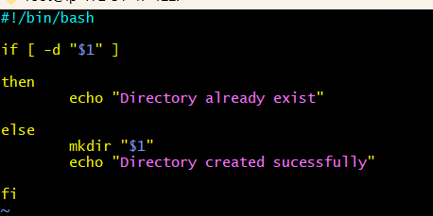

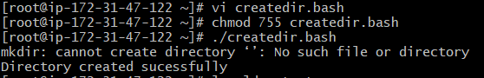

- Create a bash script to delete the last 3 lines of a file. Create vi test.txt

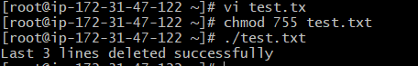

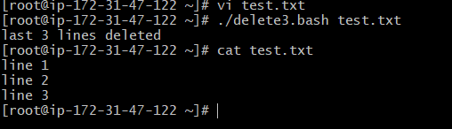

- Bash script to monitor cpu and if it is more than 80% then send email notification. Create vi cpu.bash
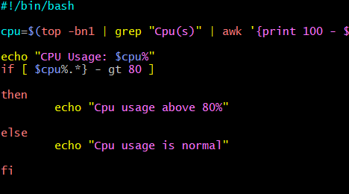

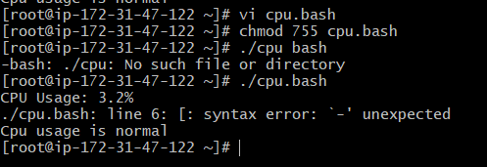]

- Bash script to monitor disk space and if it is more than 80% then send email notification. Create disk.bash
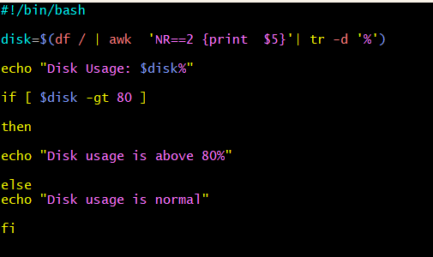

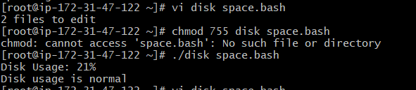
- Bash script to monitor memory and if it is more than 80% then send email notification. Create memory.bash
